**MIT School of Engineering**

**Department of Computer Science and Engineering**

**Project Synopsis**

**Group ID: 05**

**Project Title: Alzheimer's disease Prediction using Deep Learning.**

**Group Members: 04**

|  |  |  |  |  |
| --- | --- | --- | --- | --- |
| **Enrollment Number** | **Roll No.** | **Name of student** | **Email Id** | **Contact Number** |
| **MITU22BTCSD041** | **D22230340** | **Shaaz Mukadam** | **shaazmukadam16@gmail.com** | **7715034816** |
| **MITU21BTCS072** | **2213734** | **Vishal Sakale** | **Vishalsakale21@gmail.com** | **9420472707** |
| **MITU21BTCS0004** | **2213832** | **Aadityanarayan jha** | **9657074260adityajha@gmail.com** | **7350685408** |
| **MITU22BTCS0420** | **2213815** | **Pratham Desai** | **Prathamdesai2211@gmail.com** | **9403353360** |

**Problem Statement:**

**Alzheimer's disease Prediction using Deep Learning.**

**Abstract:**

Abstract through relies on concept and things that are not concrete, such as time. Both perception and abstract thinking abilities are lost fairly early in progressive dementia. For a person living with dementia, many of the concept they had once utilize no longer hold the same meaning.

In recent years numerous studies have achieved promising results in Alzheimer’s Disease (AD) detection using automatic language processing. We systematically review these articles to understand the effectiveness of this approach, identify any issues and report the main findings that can guide further research.

**Literature Survey: Detail survey done**

While some studies included up to 3 different datasets for different experiments, a few datasets were used more than once across the studies. The conditions considered in this study were AD and MCI. Although MCI did not feature in the search terms, we decided not to exclude the studies focusing solely on MCI because while MCI patients do not meet the diagnostic criteria of dementia, they can sometimes convert to AD. The studies may therefore provide an insight into the early stages of the disease as well as capture the characteristics of those MCI patients who develop AD and of those who do not. To address the heterogeneity this approach creates, the studies focusing on MCI are looked at separately from the studies concerned with AD detection. Two studies also included other dementia groups (early dementia and mixed dementia) but as both groups only appear once in the dataset, these groups were not included in further analyses.

64% of all studies reported participants’ gender and age. The average number of male participants was 35, and female participants was 50. The number of male and female participants was stated to be balanced in 13 studies and notable differences in the number of male and female participants appeared in 15 studies. There were significant differences in participants’ average age between healthy control (66.94 ± 5.75) and AD group (74.75 ± 4.36), t(30) = −4.223, P = .000, and between MCI (70.21 ± 5.64) and AD group (74.75, ± 4.36), t(25) = −2.351, P = .027. The participants’ education level was considered in 45% of the studies. The control group participants had spent, on average, more years in education than the impaired group in all but 1 study where the participants’ education level was considered.

**Proposed System (Block Diagram):**

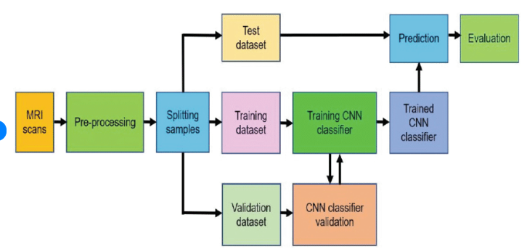

**Conclusion:**

**Our proposed method is suitable for working with a shallow CNN network for low-resolution MRI**

**and DTI scans. It yields to significant results even if the model is trained on small datasets, which is often the**

**case in medical image analysis**

**References:**

**[1] A. Association, 2018 Alzheimer’s disease facts and figures, Alzheimer’s Dement.**

**14 (3) (2018) 367–429.**

**[2] C.A. Lane, J. Hardy, J.M. Schott, Alzheimer’s disease, Eur. J. Neurol. 25 (1) (2017)**

**59–70.**

**[3] Alzheimer’s Disease International (AZ) World Alzheimer Report 2016,**

**Alzheimer’s Disease International, London, UK, https://www.alz.co.uk/research/**

**WorldAlzheimerReport2016.pdf/, 2016. (Accessed 12 December 2017).**

**[4] L. Minati, T. Edginton, M. Grazia Bruzzone, G. Giaccone, Reviews: current concepts**

**in Alzheimer’s disease: a multidisciplinary review, Am. J. Alzheimer’s Dis. Other**

**Dement. 24 (2) (2009) 95–121.**

**[5] G.B. Frisoni, N.C. Fox, C.R. Jack Jr., P. Scheltens, P.M. Thompson, The clinical use**

**of structural MRI in Alzheimer disease, Nat. Rev. Neurol. 6 (2) (2010) 67.**

**[6] B. Deweer, S. Lehericy, B. Pillon, M. Baulac, J. Chiras, C. Marsault, Y. Agid, B.**

**Dubois, Memory disorders in probable Alzheimer’s disease: the role of hippocam-**

**pal atrophy as shown with MRI, J. Neurol. Neurosurg. Psychiatry 58 (5) (1995)**

**590–597.**

**[7] B.C. Dickerson, I. Goncharova, M. Sullivan, C. Forchetti, R. Wilson, D. Bennett,**

**L.A. Beckett, L. deToledo Morrell, MRI-derived entorhinal and hippocampal atro-**

**phy in incipient and very mild Alzheimer’s disease, Neurobiol. Aging 22 (5) (2001)**

**747–754.**

**[8] H. Braak, E. Braak, Neuropathological stageing of Alzheimer-related changes, Acta**

**Neuropathol. 82 (4) (1991) 239–259.**

**[9] C.R. Jack, R.C. Petersen, Y.C. Xu, P.C. O’Brien, G.E. Smith, R.J. Ivnik, B.F. Boeve,**

**S.C. Waring, E.G. Tangalos, E. Kokmen, Prediction of AD with MRI-based hippocam-**

**pal volume in mild cognitive impairment, Neurology 52 (7) (1999) 1397–1403.**

**[10] D. Le Bihan, H. Johansen-Berg, Diffusion MRI at 25: exploring brain tissue structure**

**and function, NeuroImage 61 (2) (2012) 324–341.**

**Annexure:**

**Annexure I: Form A-Title Approval (for offline mode)**

**Annexure II: Form B-Market and financial feasibility (verify from guide)**

**Annexure III: Literature survey paper or links**